# CAREER OBJECTIE

Outgoing, motivated team player eager to contribute dynamic customer service, Administrative, supervisory, team building, and organizational skills towards supporting the objectives of an organization that rewards reliability, dedication, and solid work ethics with opportunities for professional growth.

# CONTACT

## Address:

Kathmandu Metrocity Koteshwor-32, Nepal

## Phone:

+977- 9821884720

+977- 9746824106

Email: [razzsha99@gmail.c](mailto:razzsha99@gmail.c) om

# PROFESSIONALS:

* Working as software manage and installation.
* Collaboration with other developer teams.
* Being creative when solving problems.
* Experience of working on a wide range of projects.
* Not easily distracted whilst working.
* Dealing with software demo and

Raj Babu Kumar Sah

# EDUCATION

**Shree Nrishing Higher Secondary School Birgunj (Nepal)**

+2 in Diploma in Computer Engineering

# WORK EXPERIENCE QUALTOSOFT Pvt. Ltd. (2022-2023)

Software Installation

* + Manage Software Installation
  + Collaborate with other developer’s teams

Client Support

* + Manage Client Support
  + Project Presentation and on site problem solving.

Software Demo

* + Providing a detailed software demonstration.
  + Providing necessary training on uses of software.
  + Data Entry and interpretation.

# ViaNet Communication Ltd. (2023-2024)

* L1 Support, Ticket Closing, Telnet, Network Incident
* Fields support calls from users with inquiries regarding internet connectivity
* Install, configure, test, maintain, monitor and troubleshoot problem related to connectivity

# SKILLS

**HOBBIES**:

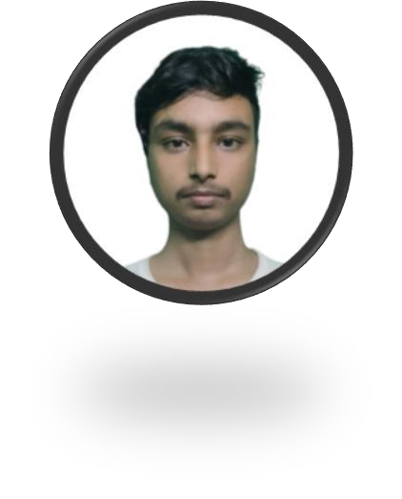

* Gaming
* Gardening
* Cooking
* Music
* Traveling

Technical Skills Communication Skills Project Management Problem Solving

Fiber Work Leadership